

*Geophysical Research Letters*

Supporting Information for

**Constrained Projections Indicate Less Delay in Onset of Summer Monsoon over the Bay of Bengal and South China Sea**

Yifeng Cheng1, Lu Wang1,2*, Xiaolong Chen3, Tianjun Zhou3, 4, Andrew Turner5,6, Lijuan Wang1

1Key Laboratory of Meteorological Disaster, Ministry of Education (KLME) / Collaborative Innovation Center on Forecast and Evaluation of Meteorological Disasters (CIC-FEMD), Nanjing University of Information Science and Technology, Nanjing, China.

2Laboratory for Regional Oceanography and Numerical Modeling, Qingdao Marine Science and Technology Center, Qingdao, China

3State Key Laboratory of Numerical Modeling for Atmospheric Sciences and Geophysical Fluid Dynamics, Institute of Atmospheric Physics, Chinese Academy of Sciences, Beijing, China.

4College of Earth and Planetary Sciences, The University of Chinese Academy of Sciences, Beijing, China.

5National Centre for Atmospheric Science, University of Reading, Reading, UK

6Department of Meteorology, University of Reading, Reading, UK

**Contents of this file**

Texts S1 to S3

Table S1

Figures S1 to S6

**Introduction**

The supporting information describes the monsoon onset indices (see Text S1), the hierarchical statistical framework for emergent constraint (see Text S2) and the leave-one-out perfect model test (see Text S3) in detail. In addition, the information about the 25 CMIP6 models used in this study (see Table S1) are also listed.

**Text S1. Monsoon onset indices**

Xing et al. (2016) devised an index for BoB monsoon onset, in which the onset date is determined as the first day after April 1 on which the averaged 925-hPa zonal wind over 2.5°-10°N, 80°-95°E is greater than 3.0 m s-1 in the following 7 days. Kajikawa and Wang (2012) devised an index for SCS monsoon onset, where the onset date is defined as the first day after April 25 that satisfies three criteria: 1) on the onset day and the following 5 days, the SCS monsoon onset (SCSSM) index, i.e., the averaged 850-hPa zonal wind over 5°-15°N, 110°-120°E, is greater than 0, indicating a steadily established westerly; 2) in the following 20 days, the SCSSM must be positive for at least 15 days; and 3) the cumulative 20-day mean SCSSM index must be greater than 1 m s-1.

**Text S2.** **Hierarchical statistical framework for emergent constraint**

The hierarchical emergent constraint framework proposed by Bowman et al. (2018) is used to constrain the projection uncertainty of monsoon onset. In this framework, we should establish a connection between future climate change *Y* and current climate *X* to constrain *Y*. The connection between *Y* and *X* can be obtained by the linear regression from climate models, that is:

|  |  |  |
| --- | --- | --- |
|  | $Y = \overline{Y} + ρ\left(X - \overline{X}\right)$, | (1) |

where $ρ$ is the regression coefficient, $\overline{X}$ and $\overline{Y}$ are the MMM of $X$ and $Y$, respectively.

Since $Y$ is constrained by the observed $X$ in current climate (${\text{X}}_{\text{O}}$), the uncertainty in observations should be considered. Under the Gaussian assumption that relates the observation to current climate, the signal-noise ratio (SNR) in the observation is the ratio between the variance among modes ($σ_{X}^{2}$) and observational datasets ($σ_{O}^{2}$):

|  |  |  |
| --- | --- | --- |
|  | SNR = ${σ_{X}^{2}}/{σ_{O}^{2}}$, | (2) |

The regression coefficient $ρ$ is corrected by multiplying $\frac{1}{1+{\text{SNR}}^{-1}}$. If the SNR is large enough (SNR $≫$ 1), the effect of correction can be neglected. Hence, combining Eqs. (1) and (2), the constrained projection and variance of future climate change $Y_{C}$ can be written as:

|  |  |  |
| --- | --- | --- |
|  | $\overline{Y_{C}}= \overline{Y}+ \frac{ρ}{1+{\text{SNR}}^{-1}} \left(\overline{X_{O}}- \overline{X}\right)$, | (3) |
|  | $σ_{Y_{c}}^{2}=(1- \frac{r^{2}}{1+{\text{SNR}}^{-1}})σ_{Y}^{2}$, | (4) |

where *r* is correlation coefficient between *X* and *Y*. Based on Eq. (4), the relative variance reduction (1 $-\frac{σ_{Y_{c}}^{2}}{σ_{Y}^{2}}$) derived from the hierarchical statistical framework is $\frac{r^{2}}{1+{\text{SNR}}^{-1}}$.

**Text S3. Leave-one-out perfect model test**

To evaluate the skill of constrained projection, we apply a leave-one-out perfect model test (Chen Z. et al., 2023; Hu et al., 2024). The brief descriptions are given below by taking model k as an example:

1. The model k is removed from the CMIP6 models to take as the pseudo-observation.
2. The AcP(B-S) change in other models would be constrained by using the pseudo-observation WP SST of model k, based on the Eq. (3).
3. We repeat the steps above for all models and obtain the constrained projections for each model.
4. To measure the quality of constrained projection, we calculate the root mean square error (RMSE) between the constrained projection and pseudo-observation. In addition, we also calculate the RMSE between the raw projection and pseudo-observation for comparison. Lower RMSE value for the constrained projection relative to the unconstrained projection indicates an improvement of the constrained projection compared to the unconstrained projection, suggesting high-quality constrained projections. The RMSE is defined as:

$RMSE=\sqrt{\frac{1}{n}\sum_{k=1}^{n}{{(\overline{Y_{C_{k}}}-Y_{{PSE}_{k}})}^{2}}}$ (5)

where $\overline{Y_{C_{k}}}$ denotes the constrained projection of $\text{∆}$ AcP(B-S), $Y_{{PSE}_{k}}$ denotes the pseudo-observation of $\text{∆}$ AcP(B-S) in model k.

**Table S1.** Basic information of 25 CMIP6 models used in this study.

|  |  |
| --- | --- |
| **Model Name** | **Institute/Country** |
| ACCESS-CM2 | CSIRO/Australia |
| ACCESS-ESM1-5 | CSIRO/Australia |
| BCC-CSM2-MR | BCC-CMA/China |
| CanESM5 | CCCma/Canada |
| CESM2-WACCM | NCAR/USA |
| CMCC-CM2-SR5 | CMCC/Italy |
| CMCC-ESM2 | CMCC/Italy |
| E3SM-1-0 | E3SM-Project/USA |
| EC-Earth3 | EC-Earth-Consortium/Europe |
| EC-Earth3-CC | EC-Earth-Consortium/Europe |
| EC-Earth3-Veg | EC-Earth-Consortium/Europe |
| EC-Earth3-Veg-LR | EC-Earth-Consortium/Europe |
| GFDL-CM4 | NOAA-GFDL/USA |
| GFDL-ESM4 | NOAA-GFDL/USA |
| INM-CM4-8 | INM/Russia |
| INM-CM5-0 | INM/Russia |
| IPSL-CM6A-LR | IPSL/France |
| KIOST-ESM | KIOST/Korea |
| MIROC6 | MIROC/Japan |
| MPI-ESM1-2-HR | MPI-M/Germany |
| MRI-ESM2-0 | MRI/Japan |
| NESM3 | NUIST/China |
| NorESM2-LM | NCC/Norway |
| NorESM2-MM | NCC/Norway |
| TaiESM1 | AS-RCEC/China |

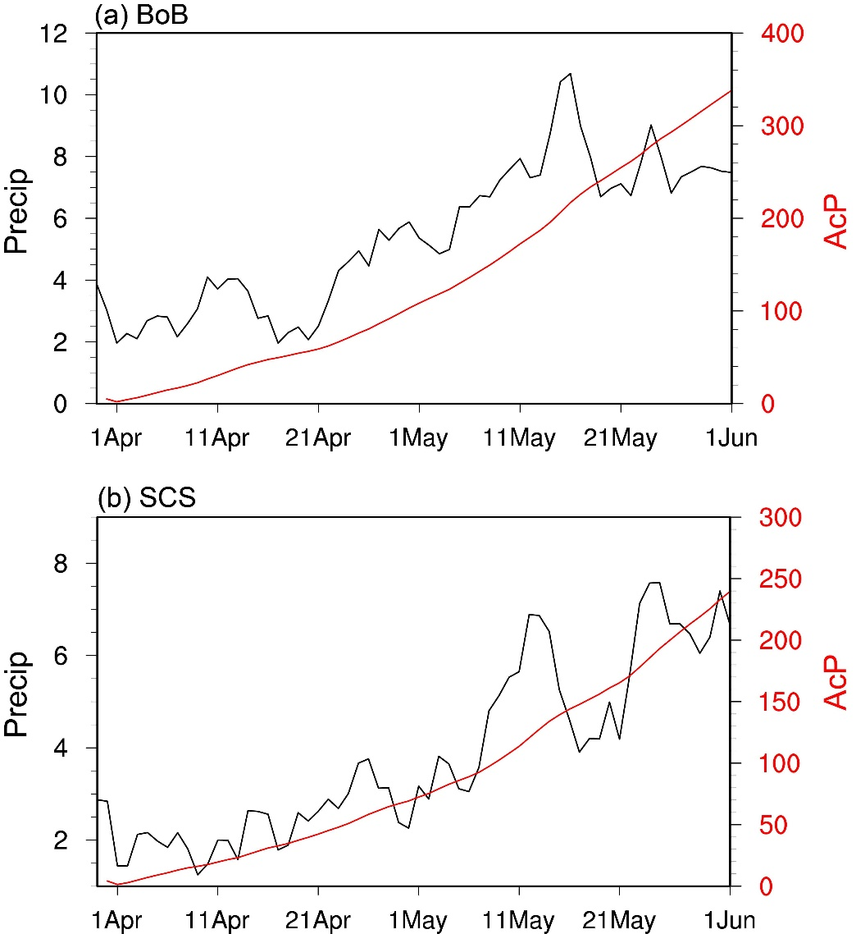

**Figure S1.** Daily climatology of precipitation (black curve; mm day-1) during April to May averaged over the (a) BoB and (b) SCS, and the corresponding AcP (red curve; mm day-1). Here, the precipitation date is derived from the Global Precipitation Climatology Project (GPCP) (Adler et al., 2003).

**Figure S2.** Observed monsoon onset anomaly during 1997-2018 over the (a) BoB and (b) SCS. The results are obtained from the AcP index (ordinate, units: mm day-1) and calculated following Xing et al. (2016) and Kajikawa and Wang (2012) (abscissa, units: days), respectively. The calculation of the monsoon onset indices defined by Xing et al. (2016) and Kajikawa and Wang (2012) are introduced in Text S1. Here, the horizontal winds are derived from the ERA-Interim reanalysis (Dee et al., 2011) and the precipitation date is derived from the GPCP. Black fitting line is obtained by the least square method, and dashed curves represent the 95% confidence range of the linear fit. The correlation coefficient (r) and p value are shown on the top right corner.

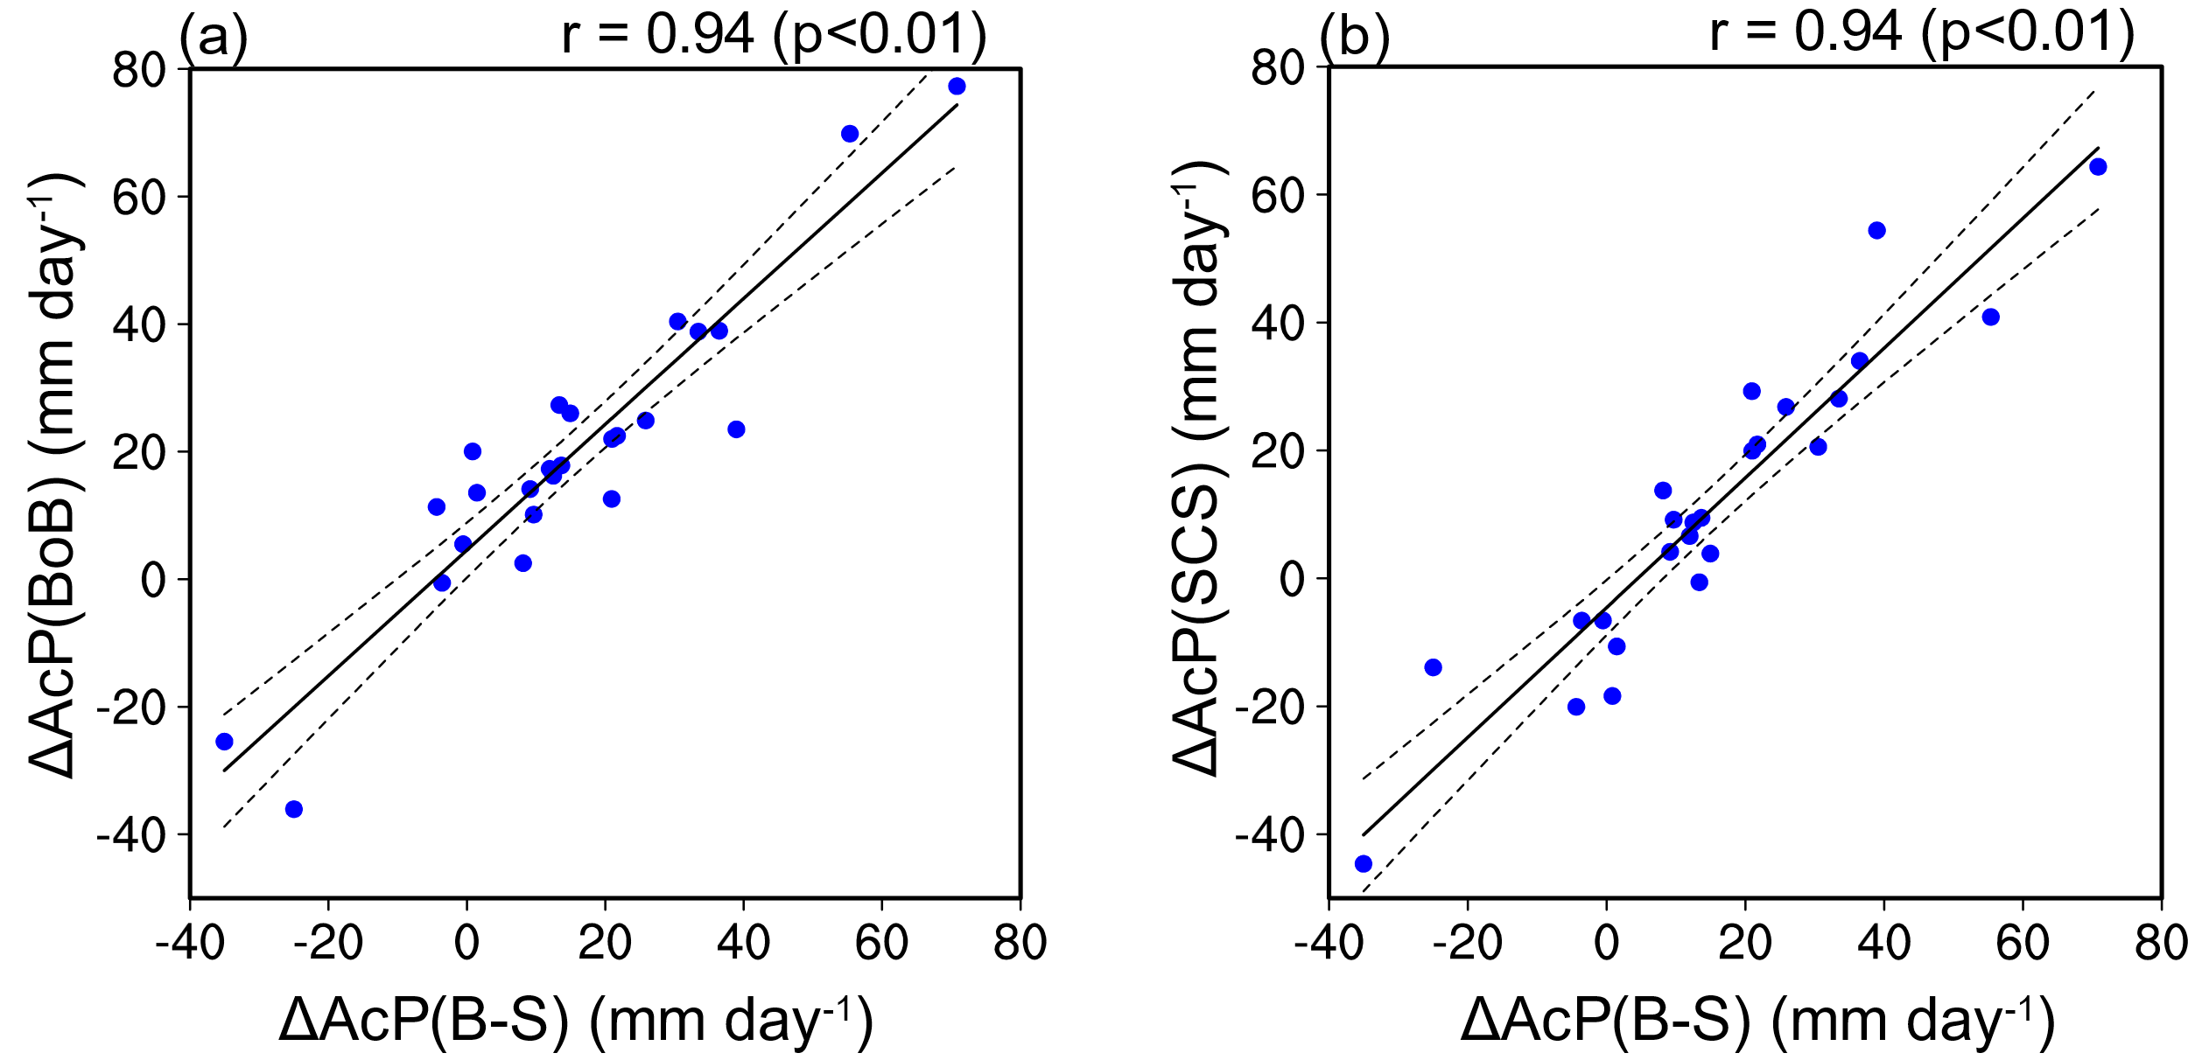

**Figure S3.** Intermodel relationships between the (a) $\text{∆}$ AcP(B-S) (mm day-1) and AcP(BoB) (mm day-1), (b) AcP(B-S) and AcP(SCS) (mm day-1). Note that all projected changes are multiplied by -1. Black fitting line is obtained by the least square method, and dashed curves represent the 95% confidence range of the linear fit. The intermodel correlation coefficient (r) and p value are shown on the top right corner.

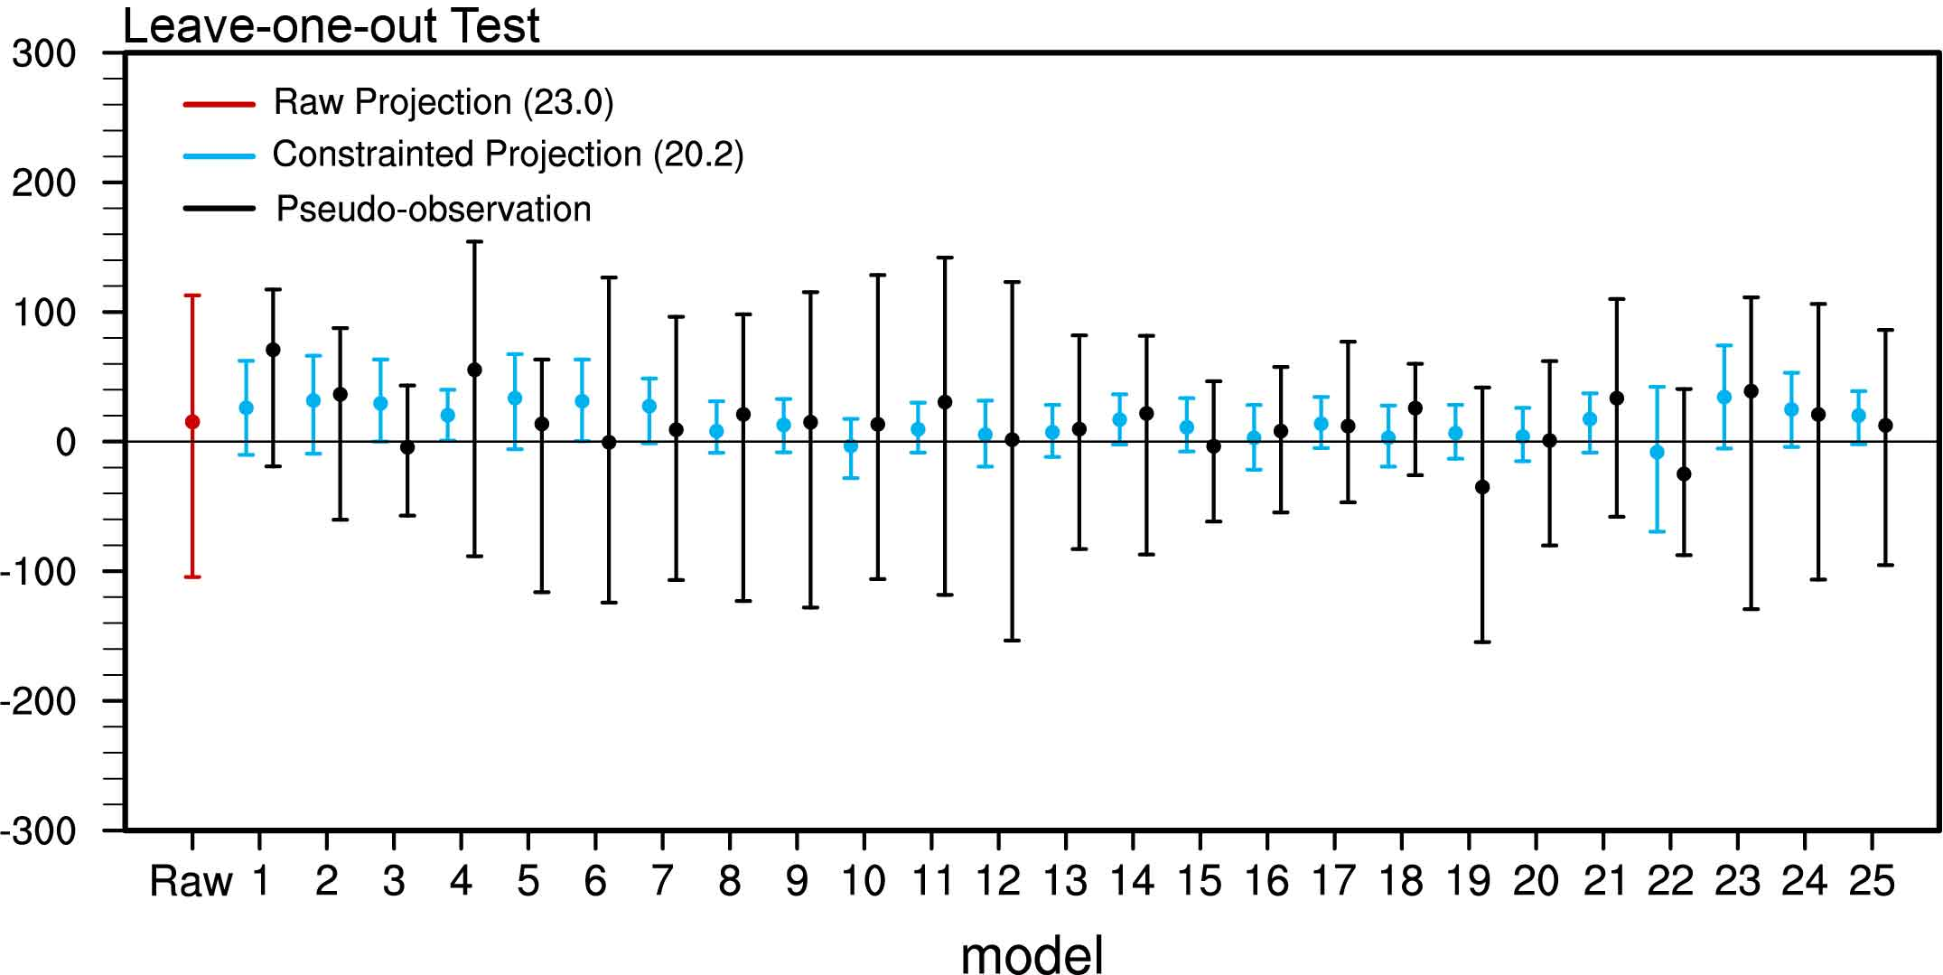

**Figure S4.** The leave-one-out perfect model test for the $\text{∆}$ AcP(B-S). The projection of the targeted model is removed and regarded as the pseudo-observation (black). The projection of the other models is constrained by using the historical WP SST of the targeted model (blue). The raw projections (red) are also shown. The dots represent the multi-model mean results, and the vertical lines represent the range of the 5th and 95th percentiles. For the target model, the range is denoted by the spread of the 5th and 95th percentiles of the $\text{∆}$ AcP(B-S) for 2049-2099. The values in the parentheses represent the root mean square errors (RMSE) of the raw and unconstrained projections, respectively. The reduction in the RMSE of the constrained projections relative to the raw projections means that the constrained result is closer to the pseudo-observation.

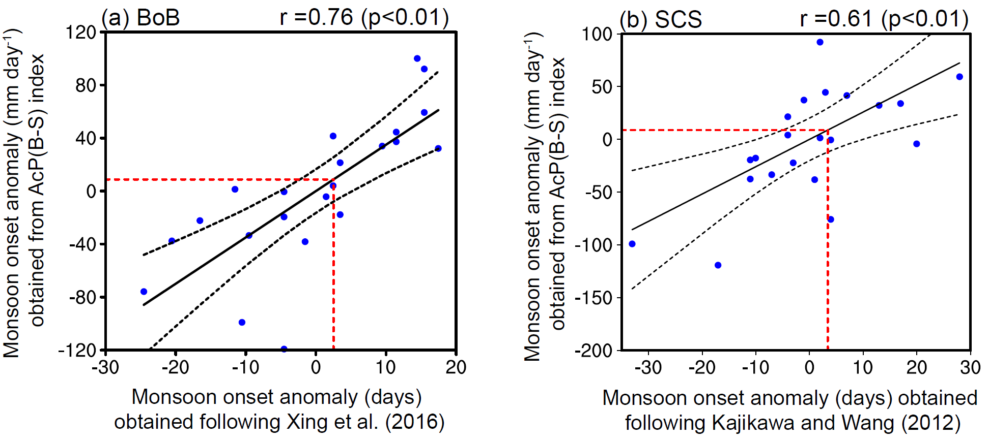

**Figure S5.** Observed monsoon onset anomaly during 1997-2018 over the (a) BoB and (b) SCS. The results are obtained from the AcP(B-S) index (ordinate, units: mm day-1) and calculated following Xing et al. (2016) and Kajikawa and Wang (2012) (abscissa, units: days), respectively. Here, the horizontal winds are derived from the ERA-Interim reanalysis and the precipitation date is derived from the GPCP. Black fitting line is obtained by the least square method, and dashed curves represent the 95% confidence range of the linear fit. The correlation coefficient (r) and p value are shown on the top right corner. The red horizontal line represents the constrained $\text{∆}$ AcP(B-S), while the vertical dashed line denotes the monsoon onset anomaly accordingly.

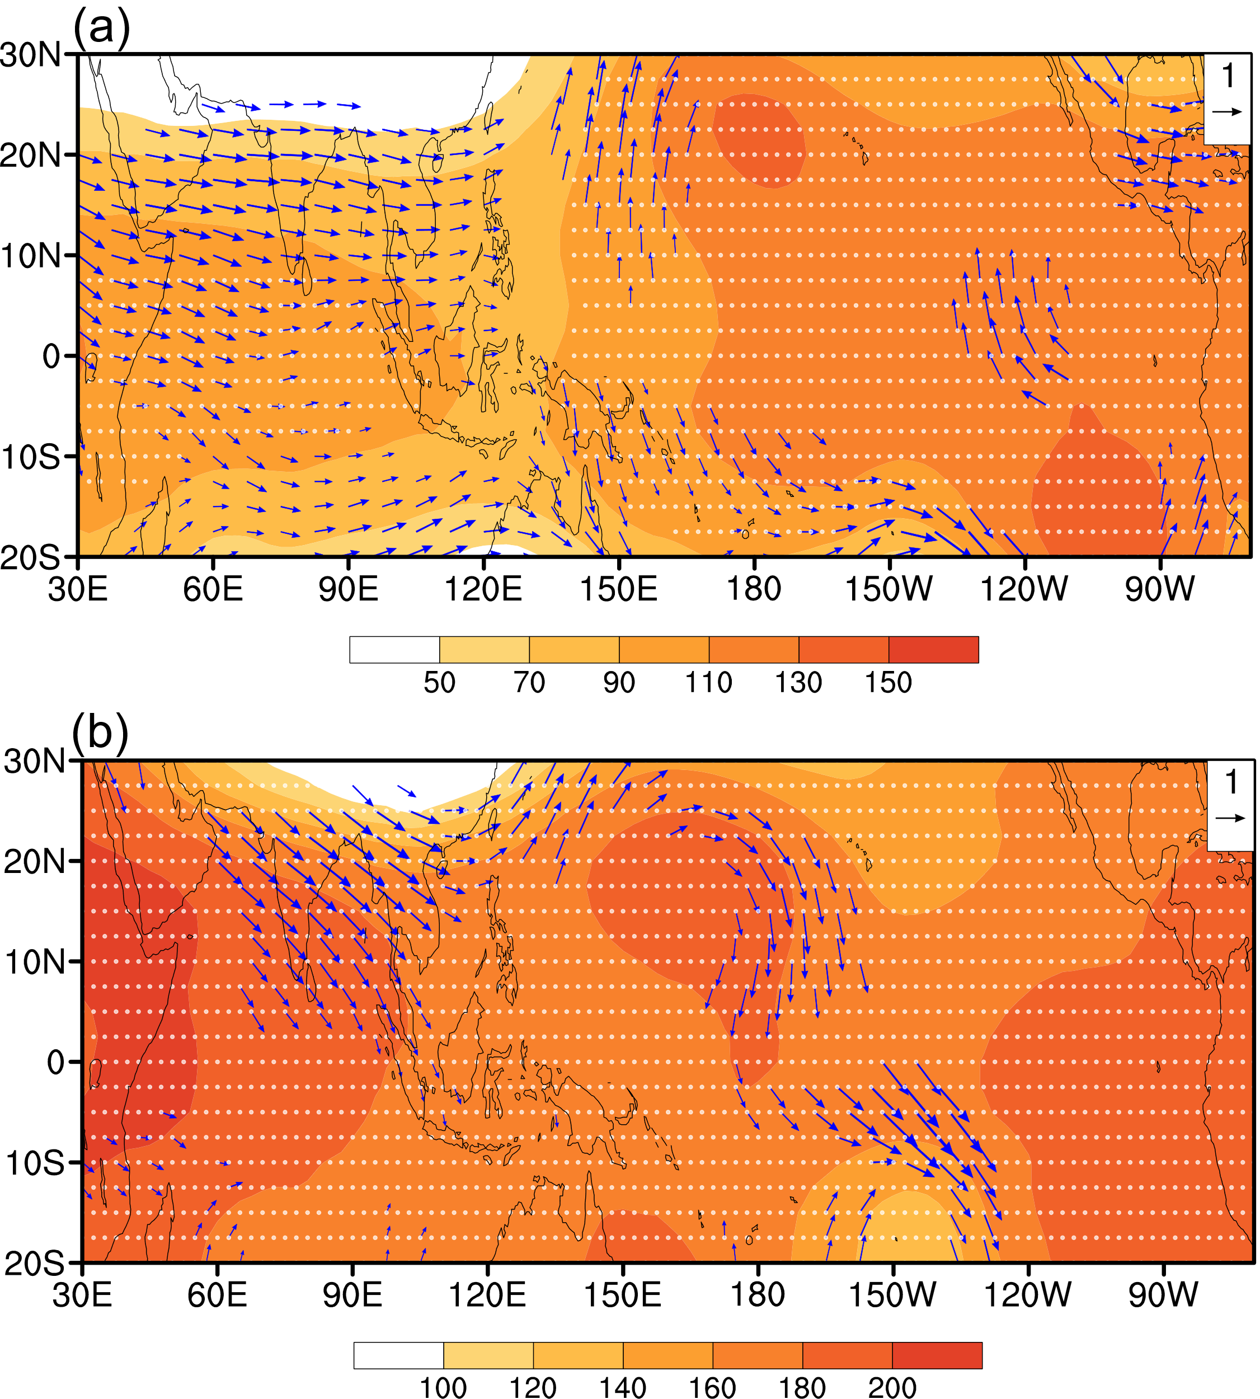

**Figure S6.** Projected changes in 500-200 hPa thickness (shading; m) and 200-hPa wind (vectors; m s-1) during February-March regressed against the normalized SST changes over the (a) equatorial central and eastern Pacific (5°S-5°N, 170°W-120°W) and (b) the southwestern Indian Ocean (10°S-0°, 40°E-50°E) among models. The vectors are shown when the zonal or meridional winds exceed the 95% significance level. The regions exceeding the 90% significance level are marked by dots.

**References**

Adler, R. F., et al. (2003). The version-2 Global Precipitation Climatology Project (GPCP) monthly precipitation analysis (1979–present). *Journal of Hydrometeorology*, *4*(6), 1147–1167. [https://doi.org/10.1175/1525-7541(2003)004<1147:TVGPCP>2.0.CO;2](https://doi.org/10.1175/1525-7541(2003)004%3C1147:TVGPCP%3E2.0.CO;2)

Bowman, K. W., Cressie, N., Qu, X., & Hall, A. (2018). A hierarchical statistical framework for emergent constraints: application to snow‐albedo feedback. *Geophysical Research Letters*, *45*(3), 13050-13059. <https://doi.org/10.1029/2018GL080082>

Chen, Z., Zhou, T., Chen, X., Zhang, W., Zuo, M., Man, W., & Qian, Y. (2023). Emergent constrained projections of mean and extreme warming in China. *Geophysical Research Letters*, *50*(20), e2022GL102124. <https://doi.org/10.1029/2022GL102124>

Dee, D. P., Uppala, S. M., Simmons, A. J., Berrisford, P., Poli, P., Kobayashi, S., ... & Vitart, F. (2011). The ERA‐Interim reanalysis: Configuration and performance of the data assimilation system. *Quarterly Journal of the royal meteorological society*, *137*(656), 553-597. https://doi.org/10.1002/qj.828

Hu, S., Wang, L., Chen, X., Zhou, T., & Hsu, P. C. (2024). Emergent constraints on future projections of Tibetan Plateau warming in winter. *Geophysical Research Letters*, *51*(9), e2024GL108728. <https://doi.org/10.1029/2024GL108728>.

Kajikawa, Y., & Wang, B. (2012). Interdecadal change of the South China Sea summer monsoon onset. *Journal of* Climate, *25*(9), 3207–3218. <https://doi.org/10.1175/JCLI-D-11-00207.1>

Xing, N., Li, J., Jiang, X., & Wang, L. (2016). Local oceanic precursors for the summer monsoon onset over the Bay of Bengal and the underlying processes. *Journal of Climate*, *29*(3), 8455–8470. <https://doi.org/10.1175/JCLI-D-15-0825.1>